** NextBook Instructions**

NextBook is intended to automatically create folders that have an archive reference number sequential from the previous one. The books don’t need to be year sequential since you can put an option to edit it.

**Installation:**

* Copy NextBook folder to a directory of your choice (try not to choose the root C:\)
* Open Macroworks:

1. Choose and press the xkey button to hold NextBook ( if the button has other things in it choose clear all)
2. In the recording layout choose the *Shortcut* Option.
3. Go to *File* button and browse for the NextBook.exe file in its folder.
4. Push *Save* button.
5. Exit MacroWorks.

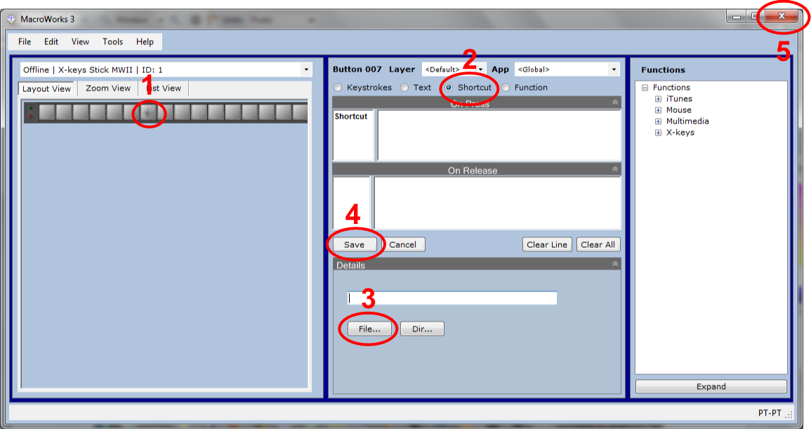

If your use of NextBook corresponds to the default options then it´s ready to use.

**Options available:**

|  |  |  |  |
| --- | --- | --- | --- |
| **Option** | **Description** | **Command line identifier** | **Values** |
| **Cover** | Choose the crop position for the first automatic cover capture (Dcam Xkeys Bar) | cover= | 1 to 8 |
| **Evaluate** | Choose to automatically evaluate the previous book, before it makes the new one. | Eval= | Yes or No |
| **Year** | 0: maintain the same date as previous book  1: Add one year unity to the previous book date    2: Stop at the first year box the input the pretended value *  3: Stop at the 3 year boxes to input the pretended values for the first* | Year= | 0 to 3 |
| **Next Crop** | Crop to be chosen after the cover capture (Dcam Xkeys Bar) | Nextcrop= | 1 to 8 |
| **Locality Levels** | Adjust NextBook to how many locality levels you are working . | Nlocal= | 2 to 4 |
| **Preview** | Choose to activate preview after crop selection | Prev= | Yes or No |
| **Cancel** | Instant cancel the procedure | ----- | ESC key |

* The year options number 2 and 3, will stop the procedure in the year box, you will then be able to change the date manually (Which **enables NextBook to work in sequential books with non-sequential years**), to resume operation press ENTER. If the user doesn’t change the year NextBook will automatically check the year correct box)

**Default Options**:

* No evaluation.
* Crop nº 1 for Cover.
* + 1 Year add.
* 4 Levels of Locality´s (Country, District, City, Locality).
* Next crop not active.

**Choosing Options :**

To change options you must edit MacroWorks script, to do it, select *Advanced View* in *View Menu*.

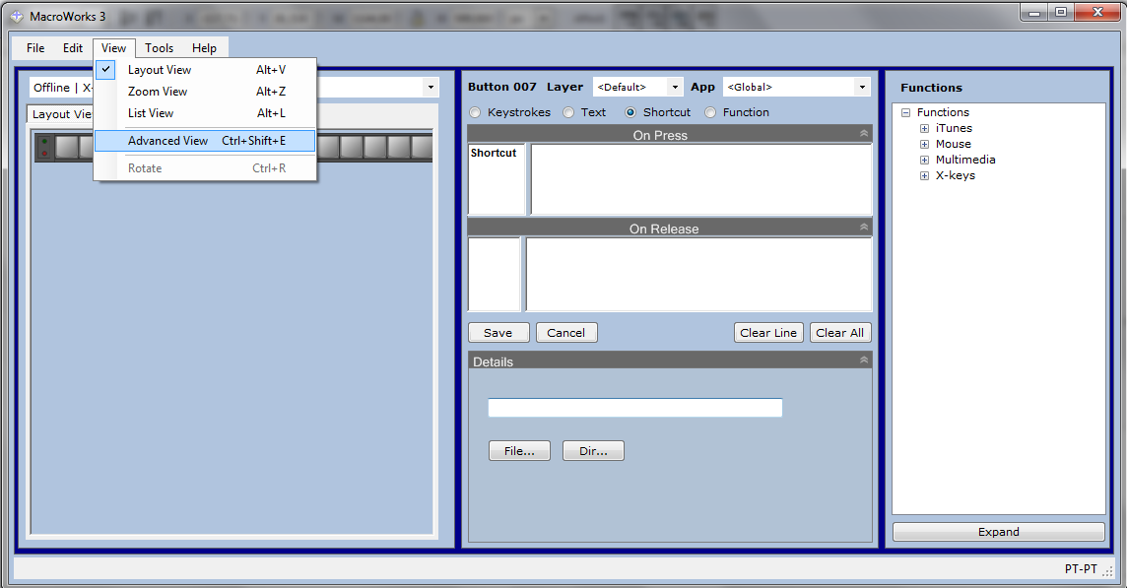

Check the number of the xkeys button where you have putted nextbook.

Inside Advanced View script editor, look for the select case that corresponds to your button, for button 1, it should look like this:

*Case 1001 'Button 001*

*If State 'Pressed [MWTAG10]*

*'<Shortcut[C:\Users\erg\Desktop\Debug\NextBook.exe]>*

***MW3.RunApp("C:\Users\erg\Desktop\Debug\NextBook.exe",Switch)***

*'</Shortcut[C:\Users\erg\Desktop\Debug\NextBook.exe]>*

*Else 'Released [MWTAG11]*

*End If 'Press-Release [/MWTAG10/MWTAG11]*

*Case 1002 'Button 002*

The Bold string is the one that you must change, it´s under the function **MW3.RunApp :**

MW3.RunApp("C:\Users\erg\Desktop\Debug\NextBook.exe",Switch)

First you must change the **Switch** in the string to **" "** :

MW3.RunApp("C:\Users\erg\Desktop\Debug\NextBook.exe" , **" "**)

To insert any options you just have to add the command line identifier (see table), followed by the pretended value (with no spaces between), each different option must be separated by a space (**If the option value that you want to input is the Default one, there´s no need to declare it).**

Examples:

* Choose to Evaluate first and to maintain the same year as the previous book:

*MW3.RunApp("C:\Users\erg\Desktop\Debug\NextBook.exe",****" Eval=yes Year=0 "****)*

* 3 Locality Levels and 3º Crop position in the Cover *MW3.RunApp("C:\Users\erg\Desktop\Debug\NextBook.exe",****" Nlocal=3 Cover=3 "****)*
* Custom Year, Next crop a Double image in the 4º positition , and make Eval.

*MW3.RunApp("C:\Users\erg\Desktop\Debug\NextBook.exe",****" Year=2 nextcrop=d4 "****)*

After editing the script, press *Build* Button in the right lower corner and push *Close* button, close also Macroworks main window and NextBook is ready to run.

**Important Notes:**

* **You can cancel the application at any time by pressing the ESC key.**
* **You can add, replace or erase any option as you need, if your option belongs to the Default ones there is no need to refer it inside the commas.**
* **With this configuration you can have different xkeys buttons with different nextbook options, as an example you can have one for adding one year to the next book and the other to customize it.**